# Calculus Primer

Review Section 1.2.2 in Goldsman, D. & Goldsman, P. (2020). A First Course in Probability and Statistics. Lulu. [Download link](https://www.lulu.com/search?page=1&q=goldsman&pageSize=10&adult_audience_rating=00)

Other resources that are helpful when reviewing calculus are:

[Paul’s Online Math Notes](https://tutorial.math.lamar.edu/)

[Khan Academy](https://www.khanacademy.org/)

[YouTube](https://www.youtube.com/results?search_query=Calculus)

<https://math.libretexts.org/Bookshelves/Calculus>

Review this playlist from 3Blue1Brown: [Essence of calculus](https://www.youtube.com/playlist?list=PLZHQObOWTQDMsr9K-rj53DwVRMYO3t5Yr)

# Why is Calculus Important?

Calculus, which encompasses both differential and integral calculus, provides a foundational mathematical framework to describe change and accumulation in various systems. Its importance to the concept of simulation is:

* Modeling Change: At its heart, differential calculus deals with rates of change. Many systems simulated in the real world, such as physical, biological, or economic systems, involve quantities that change over time. The differential equations that describe these rates of change are grounded in calculus.
* Understanding Dynamics: Many simulations aim to understand the dynamics of systems. Whether you're modeling the flight of an aircraft, the behavior of a drug in the human body, or the growth of a population, these dynamics are typically represented using equations that arise from calculus.
* Optimization Problems: Integral calculus is often used in optimization problems, where you might want to find the maximum or minimum value of a function. Simulations often incorporate optimization to determine the best possible outcome or strategy in a given scenario.
* Continuous Systems: Many systems in the real world are continuous. Calculus provides the tools to deal with continuous functions and spaces, enabling accurate simulations of these systems.
* Discretization: Even though the real world is continuous, computers operate in a discrete fashion. Techniques from calculus, especially differential equations, often need to be discretized to be solved numerically. Understanding calculus is essential to ensure this discretization is done accurately and meaningfully.
* Sensitivity Analysis: In simulations, it's often important to understand how small changes in input can affect the output. This concept of sensitivity is rooted in calculus, especially in the notion of a derivative.
* Probabilistic Simulations: Calculus often plays a role in probabilistic simulations, especially when continuous probability distributions are involved. For instance, determining the expected value of a continuous random variable involves integral calculus.
* Conservation Laws: Many physical systems are governed by conservation laws (e.g., conservation of mass, momentum, or energy). The mathematical formulations of these laws involve differential and integral calculus.
* Interdisciplinary Applications: Simulations are used across various disciplines—physics, biology, economics, medicine, and more. A fundamental understanding of calculus ensures that a practitioner can navigate and develop simulations in multiple domains.
* Foundational for Advanced Topics: As one dives deeper into the world of simulations, they may encounter more advanced mathematical topics such as partial differential equations, Fourier transforms, or Green's functions. A solid grasp of calculus is essential to understand and utilize these advanced tools.

Calculus provides the mathematical language and framework that underpin a vast majority of simulations. Whether you're modeling the minute electrical variations in a neuron or the vast, dynamic motions of galaxies, calculus offers the tools to describe, analyze, and predict system behaviors.

# Example: Find that minimizes

First, we find the first derivative of the function [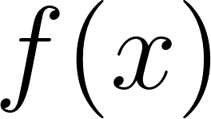](https://www.codecogs.com/eqnedit.php?latex=f(x)#0) with respect to [](https://www.codecogs.com/eqnedit.php?latex=x#0). Applying the chain rule of differentiation, we obtain:

[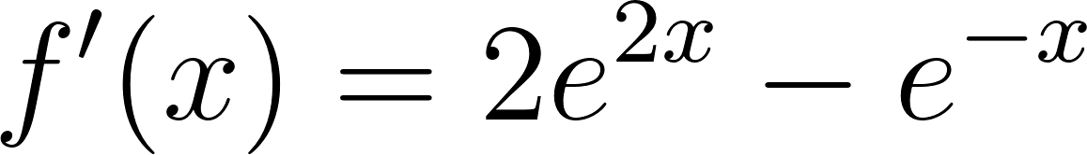](https://www.codecogs.com/eqnedit.php?latex=f'(x)%20%3D%202%20e%5E%7B2x%7D%20-%20e%5E%7B-x%7D#0)

The minimum of the function can only occur when the first derivative is equal to zero:

[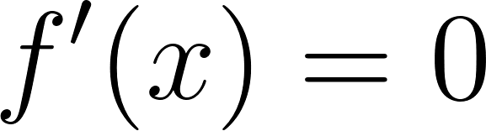](https://www.codecogs.com/eqnedit.php?latex=f'(x)%20%3D%200#0)

[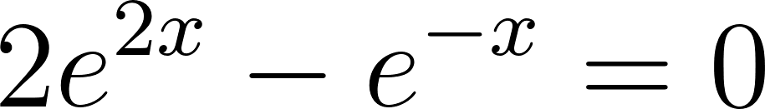](https://www.codecogs.com/eqnedit.php?latex=2%20e%5E%7B2x%7D%20-%20e%5E%7B-x%7D%20%3D%200#0)

To solve for [](https://www.codecogs.com/eqnedit.php?latex=x#0), let's multiply both sides by [](https://www.codecogs.com/eqnedit.php?latex=e%5E%7Bx%7D#0):

[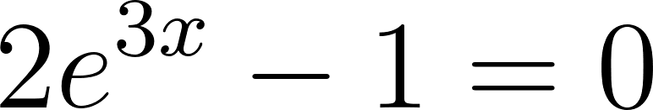](https://www.codecogs.com/eqnedit.php?latex=2%20e%5E%7B3x%7D%20-%201%20%3D%200#0)

To find the value of [](https://www.codecogs.com/eqnedit.php?latex=x#0), let's divide both side by 2:

[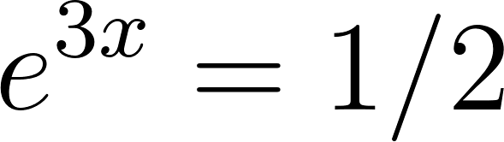](https://www.codecogs.com/eqnedit.php?latex=e%5E%7B3x%7D%20%3D%201%2F2#0)

Taking the natural logarithm of both sides:

[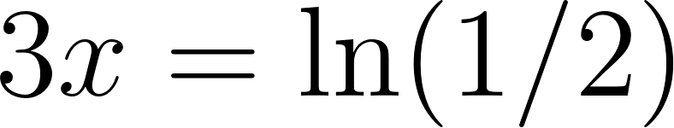](https://www.codecogs.com/eqnedit.php?latex=3x%20%3D%20%5Cln(1%2F2)#0)

[](https://www.codecogs.com/eqnedit.php?latex=3x%20%3D%20%5Cln(2%5E%7B-1%7D)%3D-%5Cln(2)#0)

Thus:

[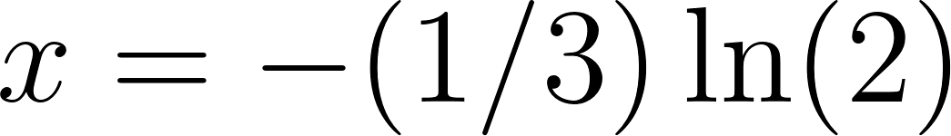](https://www.codecogs.com/eqnedit.php?latex=x%20%3D%20-(1%2F3)%20%5Cln(2)#0)

To ensure that the value of [](https://www.codecogs.com/eqnedit.php?latex=x#0) we found corresponds to a minimum, we need to check the second derivative of the function [](https://www.codecogs.com/eqnedit.php?latex=f(x)#0) . Applying the chain rule of differentiation again, we obtain:

[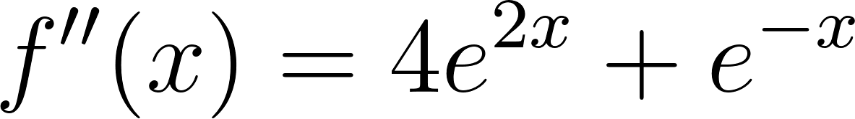](https://www.codecogs.com/eqnedit.php?latex=f''(x)%20%3D%204%20e%5E%7B2x%7D%20%2B%20e%5E%7B-x%7D#0)

Since both terms in the expression are positive, we can conclude that [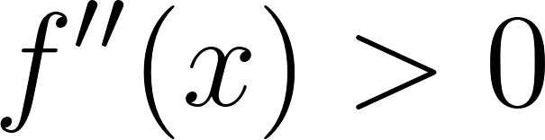](https://www.codecogs.com/eqnedit.php?latex=f''(x)%20%3E%200#0) for all [](https://www.codecogs.com/eqnedit.php?latex=x#0). This confirms that the point [](https://www.codecogs.com/eqnedit.php?latex=x%20%3D%20-(1%2F3)%20%5Cln(2)#0) corresponds to a minimum.